Technical Documentation
StoreIQ AI Perception Engine
Project Name: StoreIQ
Team Members: Mohana Dharshini T, Dharshini V
Category: AI-Powered E-Commerce Optimization Platform
Architecture: Decoupled Full-Stack System (React + Node.js + MongoDB)
AI Models: Groq (LLaMA 3.3 70B), Google Gemini 1.5 Flash
Deployment: Vercel (Frontend), Render (Backend), MongoDB Atlas (Database)

1. Executive Summary
StoreIQ is an intelligent e-commerce optimization platform designed to solve the Perception Gap — the difference between how merchants describe products and how customers understand them.
The system performs automated Shopify store audits, detects clarity and trust issues, and generates AI-powered product improvements. By combining AI intelligence with rule-based validation, StoreIQ improves product clarity, builds trust, and increases conversion potential.
2. System Architecture
StoreIQ follows a decoupled architecture consisting of three main layers:
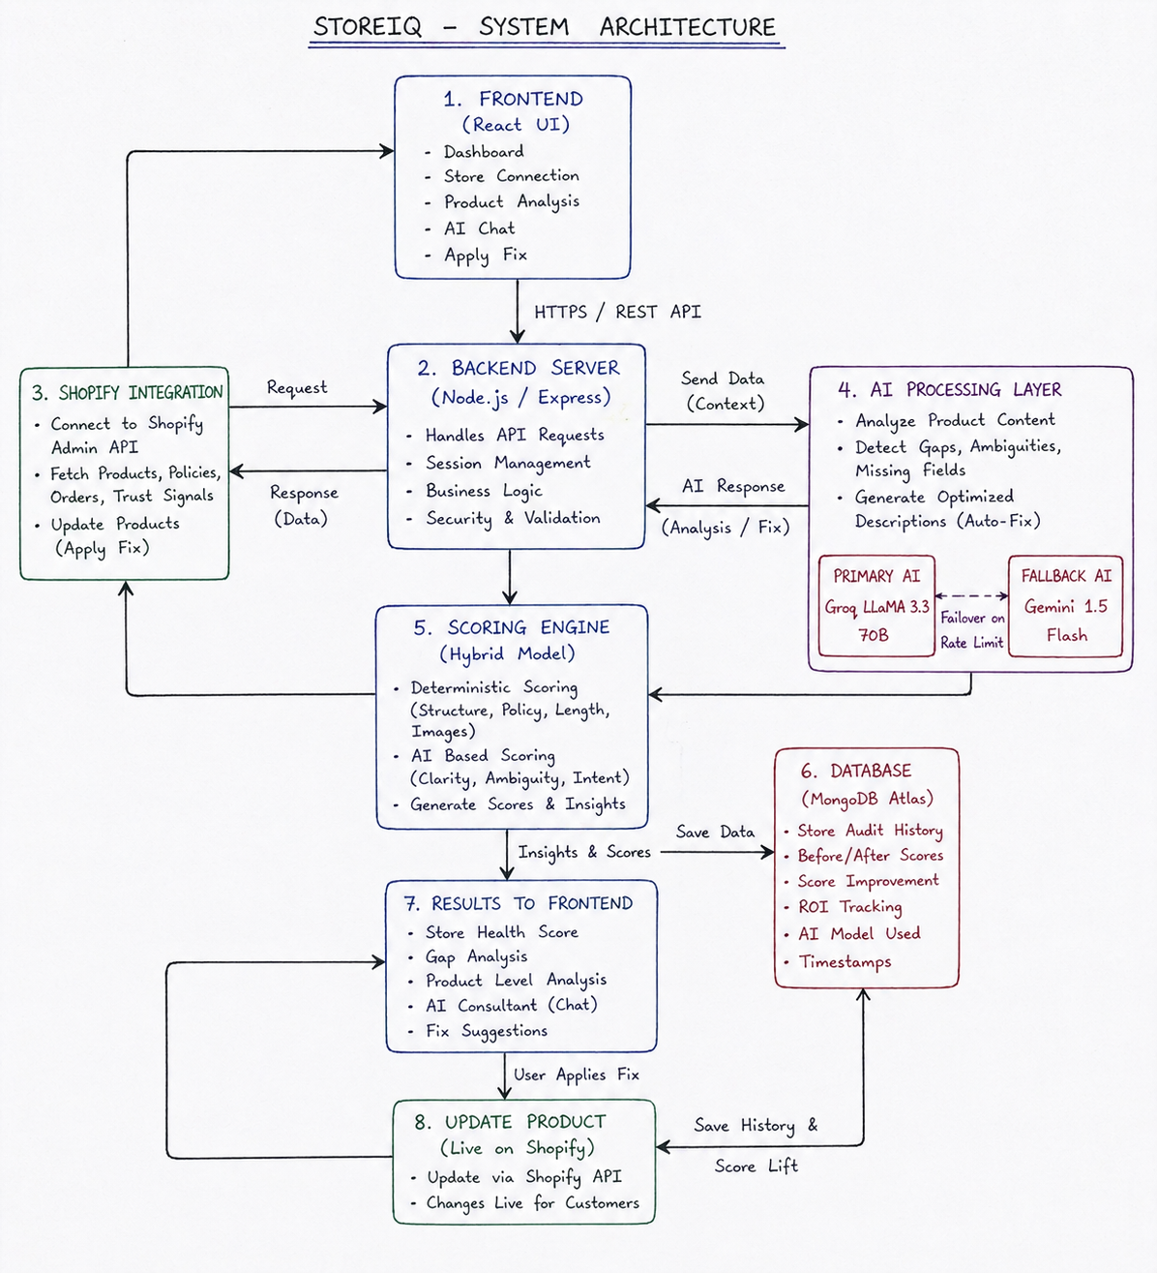

2.1 Frontend Layer
- Built using React (Vite)
- Provides dashboard for:
  - Store analytics
  - Product diagnosis
  - AI-generated fixes
- Designed with glassmorphism UI for better user experience

2.2 Backend Layer
- Built using Node.js with Express
- Handles:
  - Shopify API communication
  - AI processing
  - Scoring logic
  - Session management

2.3 Data Layer
- MongoDB Atlas for persistent storage
- Stores audit history and score improvements
- In-memory session store used for temporary connections

2.4 External Integrations
- Shopify Admin API (product data + updates)
- Groq API (primary AI model)
- Gemini API (fallback AI model)

3. AI Perception Pipeline
StoreIQ processes data using a multi-stage pipeline:
Step 1: Data Collection
Product details like title, description, and images are fetched from Shopify.

Step 2: AI Analysis
The AI reads the product description and checks:
- Is the content clear?
- Is anything missing?
- Does it match the product title?
If Groq fails (rate limit), Gemini is used automatically.

Step 3: Rule-Based Checking
The system also checks using logic:
- Is description too short?
- Are policies present?
- Are images available?

Step 4: Storage
All results are saved in MongoDB for future reference.

4. Core Technical Modules
4.1 AI Perception Engine
Analyzes product descriptions for:
- Ambiguity (unclear language)
- Missing details (size, materials, specs)
- Contradictions between title and content

4.2 Hybrid Scoring Model
Each product is assigned a score (0–100):
- Deterministic Score (40%)
  - Image count
  - Content length
  - Policy presence
- AI Score (60%)
  - Clarity
  - Relevance
  - Readability

4.3 Trust & Policy Analyzer
Checks store-level trust signals:
- Shipping policy
- Return/refund policy
- Privacy information
- Customer reviews
Missing elements reduce overall score.

5. Security & Data Handling
5.1 Token Security
- Shopify API token stored only in backend .env
- No sensitive data exposed to frontend

5.2 Session Management
- User connects store using domain
- Backend creates secure session
- All APIs require active session

5.3 AI Reliability
- Automatic fallback from Groq to Gemini
- Handles API rate limits (HTTP 429)
- Ensures uninterrupted processing

6. API Design
Authentication APIs
- POST /connect-store → Connect store
- GET /connection-status → Check session
- POST /disconnect-store → Disconnect

Audit APIs
- POST /audit/store → Full store audit
- POST /audit/auto-fix → Generate improvements

Analysis APIs
- POST /perception-analysis → Product-level analysis
- POST /chat → AI consultant

Operational APIs
- POST /update-product → Update Shopify product
- GET /history → Fetch stored audit history

7. Data Persistence & ROI Tracking
StoreIQ uses MongoDB to store long-term analytics:
- Tracks before and after scores
- Calculates score improvement (ROI)
- Maintains audit history for each product
- Logs AI model usage for performance analysis

Schema Structure
{
store_domain: String,
product_id: String,
product_title: String,
before_score: Number,
after_score: Number,
score_improvement: Number,
ai_model_used: String,
timestamp: Date
}

8. Deployment Architecture
Backend (Render)
- Node.js server deployed as Web Service
- Environment variables configured securely

Frontend (Vercel)
- React app deployed with global CDN
- Connected to backend API

Database (MongoDB Atlas)
- Cloud-hosted database
- Enables scalable storage and analytics

Required Environment Variables
GROQ_API_KEY=your_key
VITE_GEMINI_API_KEY=your_key
SHOPIFY_ACCESS_TOKEN=your_token
MONGO_URI=your_mongodb_uri
PORT=3001

9. Key Functional Workflow
- User connects Shopify store
- Backend fetches product catalog
- Audit is performed
- Scores and gaps are identified
- AI generates optimized descriptions
- User applies fix
- Product is updated live
- Data is stored for tracking

10. Key Implementation Decisions
StoreIQ uses a hybrid architecture combining AI and deterministic logic for reliability and intelligence.
AI models handle perception-based tasks such as clarity analysis and content generation, while deterministic logic ensures measurable validation like image presence and content length.
A decoupled system (React + Node + MongoDB) was chosen for scalability and flexibility.
Multi-model fallback (Groq → Gemini) ensures uninterrupted AI processing.

11. AI vs Deterministic Logic
AI is used for subjective tasks such as understanding clarity, detecting missing details, and generating improved descriptions.
Deterministic logic handles objective checks like image count, description length, and policy validation.
This separation ensures reliability in critical checks while leveraging AI for intelligent improvements.
The hybrid scoring system balances both approaches effectively.

12. Failure Handling & System Degradation
If the Shopify API fails, the system stops the audit and informs the user without crashing.
If the primary AI (Groq) fails, the system switches to Gemini automatically.
If both AI models fail, the system falls back to rule-based scoring.
Invalid AI responses are filtered, and safe fallback outputs are shown.
Unexpected user input is validated to prevent system failure.

13. Known Limitations & Future Improvements
AI suggestions may vary depending on input quality.
Image analysis is currently limited to availability checks.
System depends on external APIs, which may introduce delays.
Future improvements include advanced image analysis, better prompt tuning, and personalized recommendations.

14. Conclusion
StoreIQ presents a complete AI-driven solution to improve e-commerce product communication.
By combining AI perception analysis, rule-based validation, and real-time Shopify integration, it effectively reduces the Perception Gap.
The system enhances clarity, builds trust, and improves conversion rates, making it a scalable solution for modern e-commerce platforms.

